Decision Making Processes

7. Procedures to Appoint Members to Various Bodies

The Address Council (AC) appoints members to various positions on committees, working groups, task forces, or other bodies. This procedure will apply to such appointments, except where a more specific procedure exists.

7.1 Procedures for making the appointment

The AC shall make the appointment by Electronic Vote (eVote) and all the ASO AC members will have the right to cast their vote, following the schedule defined for the e-voting process. In case an urgent appointment is needed, the AC may replace the eVote with a decision taken in a regular or special AC meeting.

7.2. eVotes

All eVotes must have a scheduled start and end date and time, in a specified time zone. The voting must be open for no less than seven days. Approximately one day before the scheduled end of voting time, each AC member will get an email noting if their individual vote has been recorded, instructions on how to vote, and the total number of votes cast. The election will close at the end of the scheduled voting time or may close early if all AC members have voted. The successful candidate will receive a majority of votes from the ASO AC members to be appointed. In the case of a tie, the AC will gather to discuss the remaining candidates before carrying out a re-vote.

7.3 eVotes for Multiple Appointments

In the event of an election for multiple appointments, members will be permitted as many votes as there are appointments to fill. Each member may vote for as many or as few candidates as they desire, up to the maximum of the seats to be appointed, but may not submit more than one vote per candidate.

7.4. eVote Extensions

If less than half of the AC members submit their vote on time, the election will be extended by another seven days unless specific time-restrictions or requirements make the extension not possible.

When the extension proceeds, an email will be sent to all AC members announcing the new end date of the vote, and will list the names of those who have already voted. It will also include voting instructions.

E-Votes cast prior to the extension period will be counted, so there is no need to cast a new vote in the extension period if the AC member has already voted prior to the extension period.

At the conclusion of the extension period, the appointment will be based on a majority of those who voted, no matter the final number of votes cast.

7.5 E-Vote procedures

Instant Run-off voting will be the election counting mechanism used to select a candidate in a ranked preferential voting method, based on a single list of candidates, ranked in order of preference.

Voters rank candidates in order of preference (i.e. first, second, third and so on). Ballots are initially counted to establish the number of votes for each candidate. If a candidate has more than half (Majority) of the first-choice votes, that candidate wins. If not, then the candidate with the fewest votes is eliminated, and the voters who selected that candidate as their first choice have their votes added to the total of the candidate who was their next choice. That process continues until one candidate has more than half of the votes, and that person is declared the winner.

7.6 Appointment decisions in a regular or special AC meeting

If an urgent appointment is needed to be made that cannot be carried out in the normal process, e.g. due to extreme time constraints, the appointment will be made by vote of the members of the ASO AC in a regular or special meeting. In these cases, the need to decide on the appointment must be included in the meeting agenda and notified to all ASO AC members with due anticipation.

7.7. Updates from Appointees

Upon accepting an appointment, appointees shall provide regular updates to the ASO AC on their work, and the work of the body they are appointed to. The update should be provided at least twice annually. Appointees may be invited to provide updates during ASO AC meetings.

Updates may be provided via email in addition to, or instead of, attendance at a meeting.

Appointees may be invited to attend ASO AC meetings as observers, even when no updates will be provided.

8. Procedure for Removal of ASO appointed members

The same procedure used by the AC to appoint a person to a position on committees, working groups, task forces, or other bodies shall be used to removal of such appointees.

The AC may also choose to make a new appointment in parallel or contingent upon removal of a current appointee.

11. Amendment of Operating Procedures
These Operating Procedures may be amended through an eVote. The proposed amendment must receive two thirds majority support of all members of the AC to be implemented. A minimum of 7 days will be granted for AC members to submit their electronic votes, but the process can be concluded as soon as all members register a vote. All amendments to these Operating Procedures shall be approved by the Executive Council of the Number Resource Organization. Proposed amended text must be available for discussion on email at least seven days prior to the start of an eVote.

9.4.7.3 Elections Counting
Instant Run-off voting will be the election counting mechanism used to select a candidate in a ranked preferential voting method, on the basis of a single list of candidates, ranked in order of preference.

Voters rank candidates in order of preference (i.e. first, second, third and so on). Ballots are initially counted to establish the number of votes for each candidate. If a candidate has more than half of the first-choice votes, that candidate wins. If not, then the candidate with the fewest votes is eliminated, and the voters who selected that candidate as their first choice have their votes added to the total of the candidate who was their next choice. That process continues until one candidate has more than half of the votes, and that person is declared the winner.

In the case of a tie, the entire Address Council will reconvene to discuss the merits of the candidates not yet eliminated before carrying out a new IRV vote on those remaining candidates. If the candidates cannot be separated by IRV after three tie re-votes, the AC Chair team will consult the Executive Council on how to best to proceed.

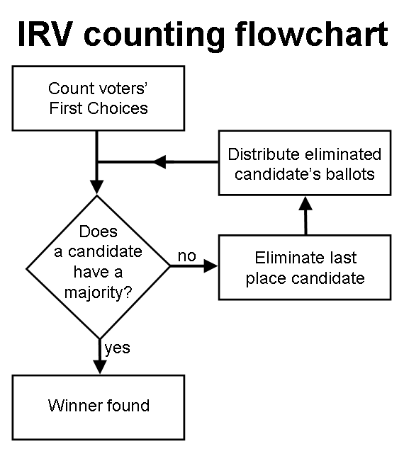

Comparison test sheet: IRV and First-past-the-post

Round 1: FPTP and IRV both result in a tie.

Round 2: the only change is ‘Voter p’ does not issue any preferential vote to Candidate A. As a result, IRV removes Candidate A as the ‘lowest voted candidate’ and declares Candidate B as the winner. Meanwhile, First-past-the-post still issues a tie.
This shows IRV to be a more nuanced and competent simple voting mechanism IMHO.

Note: four voters is used below just as an extremely low example. Unrealistically low for an ASO AC election.

 |  | Candidate A | Candidate B |  | Count Method | Candidate A | Candidate B | Result
Round 1 | Voter x | 1 | 2 |  | First-past-the-post | 2 | 2 | Tie
 | Voter y | 2 | 1 |  | IRV, round 1: over 50%? | no | no
 | Voter z | 1 | 2 |  | (IRV remove lowest voted candidate) | 4 | 4 | Tie
 | Voter p | 2 | 1
Round 2 | Voter x | 1 | 2 |  | First-past-the-post | 2 | 2 | Tie
 | Voter y | 2 | 1 |  | IRV, round 1: over 50%? | no | no
 | Voter z | 1 | 2 |  | (IRV remove lowest voted candidate) | 3 | 4 | Candidate B wins
 | Voter p |  | 1

