#### **Decision Making Processes**

#### 

#### **7. Procedures to Appoint Members to Various Bodies**

#### The Address Council (AC) appoints members to various positions on committees, working groups, task forces, or other bodies. This procedure will apply to such appointments, except where a more specific procedure exists. ~~For example, this procedure does not apply to appointment of ICANN board members, because there is a separate procedure for that.~~

#### 7.1. ~~Non Time Constrained Appointment Requests~~

#### ~~If there is sufficient time, the AC will evaluate the request to make an appointment in an ASO AC meeting. The address council may choose, by simple majority vote of the AC members attending the meeting, to~~

#### ~~make the appointment,~~

#### ~~defer until the next (planned or emergency) ASO AC meeting, or~~

#### ~~hold an electronic vote (eVote).~~

#### ~~7.2. Solicitation of Interest~~

#### ~~The AC members may decided to solicit interest from a wider group than those in attendance at the meeting, including, but not limited to:~~

#### ~~other AC members not in attendance,~~

#### ~~AC members whose term is expiring at the end of the year,~~

#### ~~AC members elect, and~~

#### ~~outside individuals, such as NRO or RIR staff, or member of the NRO/ASO community.~~

#### 

#### ~~7.3. Time Constrained~~ **Procedures for** Appointment ~~Requests~~

#### The AC Chair shall ~~may~~ decide to make the appointment by eVote after discussion on the mailing list, in order to meet appointment deadline.

#### ~~7.4~~. 7.2. eVotes

#### All eVotes must have a scheduled start and end date and time, in a specified time zone. The voting must be open for no less than seven days. Approximately one day before the scheduled end of voting time, each AC member will get an email noting if their individual vote has been recorded, instructions on how to vote, and the total number of votes cast. The election will close at the end of the scheduled voting time or may close early if all AC members have voted. The appointment **will require that one of the candidates have received a majority of ASO AC ‘s support, provided more than half of the AC members have voted.**

#### ~~be based on a relative majority if more than half of the AC members have voted~~.

#### ~~7.4.1~~. 7.3 eVotes for Multiple Appointments

#### In the event of an election for multiple appointments, members will be permitted as many votes as there are appointments to fill. Each member may vote for as many or as few candidates as they desire, **up to the maximum of the seats to be appointed.** ~~in terms of 7.4.1,~~ but may not submit more than one vote per candidate. ~~The appointments will be based on a relative majority where the candidates with the most votes will fill the available appointments, provided more than half of the AC members have voted.~~

#### ~~7.4.2. eVotes for an Unknown Number of Appointments~~

#### ~~It is possible that an eVote can be held where the number of appointments is not known in advance. In this case, members will be permitted as many votes as the number of candidates, or such smaller number as may be decided prior to the start of the eVote. Each member may vote for as many or as few candidates as they desire, up to the maximum set in terms of 7.4.2, but may not submit more than one vote per candidate. The threshold for determining an appointment must be decided prior to the start of the eVote. Some examples include but are not limited to:~~

#### ~~all candidates tied for first will be selected,~~

#### ~~all candidates within two votes of the the lead candidate will be selected,~~

#### ~~the number of votes cast for the candidate in third position will be determined, and all candidates will be selected who receive at least that many votes, or who fall short of that threshold by no more than two votes will be selected,~~

#### ~~all candidates with a simple majority of votes will be selected.~~

#### ~~7.4.3~~. **7.3**. eVote Extensions

#### If half or less of the AC have voted, the election will be extended another seven days, unless the AC Chair decides otherwise due to relevant time-restrictions or requirements at a given time. In such a situation the decision of the Chair should be explicitly documented and the AC should be informed.

#### An email will be sent to all AC members announcing the new end date of the vote, and will list the names of those who have already voted. It will also include voting instructions.

#### Votes cast prior to the extension period will be counted, so there is no need to cast a vote in the extension period if the AC member has already voted prior to the extension period.

#### At the conclusion of the extension period, the appointment will be based on a ~~relative~~ majority of those who voted.

#### ~~7.4.4~~. **7.4** eVote Runoffs

#### In the event that an eVote results in a tie, or similar circumstances, a runoff election will be held including all candidates **who produce the tie.** ~~were not eliminated during the previous round. To the greatest extent practical, the runoff election will be held in the same manner as the first round, except that, if the first round was an eVote over a period longer than seven days, then the duration of the runoff election will be reduced to seven days, unless the AC Chair decides otherwise due to relevant time-restrictions or requirements at a given time. In such a situation the decision of the Chair should be explicitly documented and the AC should be informed. A runoff election may be closed early if all ASO AC members have voted.~~ ~~This procedure is not included for appointments made in a meeting, as anomalous results can be immediately dealt with through~~

#### ~~discussion,~~

#### ~~a newly constrained vote, or~~

#### ~~a motion about how the results should be considered~~

#### 7.5. Updates from Appointees

#### Upon accepting an appointment, appointees shall provide regular updates to the ASO AC on their work, and the work of the body they are appointed to.

#### Appointees may be invited to provide updates during ASO AC meetings.

#### Updates may be provided via email in addition to, or instead of, attendance at a meeting.

#### Appointees may be invited to attend ASO AC meetings as observers, even when no updates will be provided.

#### 8. Procedure for Removal of ASO appointed members

#### The Address Council (AC) appoints members to various positions on committees, working groups, task forces, or other bodies. This procedure will apply to removal of such appointees, ~~when permitted~~, except where the ASO AC has a more specific removal procedure.

#### ~~8.1. Non Time Constrained Appointment Removal Requests~~

#### ~~If there is sufficient time, the AC will evaluate the request to remove an appointee in an ASO AC meeting.~~ The AC must ~~may choose, by simple majority vote of the AC members attending the meeting, to~~ hold a vote for appointee removal. The appointee removal vote ~~can~~ **will** be conducted via an eVote. The AC may also choose to make a new appointment in parallel or contingent upon removal of a current appointee.

#### ~~8.2. eVote~~

#### ~~The AC Chair may decide to hold an eVote after a 7 day discussion on the mailing list~~~~1~~~~. eVotes will follow the procedures described in our PROCEDURES TO APPOINT MEMBERS TO VARIOUS BODIES sections 7.4 except as follows in section in the next section:~~

#### ~~8.3. Results~~

#### ~~Only a unanimous vote to remove the appointee will result in removal.~~

#### ~~As single vote cast to not remove the appointee will result in the appointee remaining in the position.~~

#### ~~Abstentions and members not voting is acceptable, provided a simple majority of eligible voters vote in support of removing the appointee.~~

#### ~~At the conclusion of the removal eVote, if the results are inconclusive, then the vote will be extended by another 7 days. Each AC member will get an email noting if their individual vote has been recorded, instructions on how to vote, the total number of votes cast, and the new date concluding the election.~~

#### 

**11. Amendment of Operating Procedures**

These Operating Procedures may be amended ~~at any regular or special meeting of the council or~~ through an electronic vote. The proposed amendment must receive ~~four-fifths~~ **two- thirds** majority support of all members of the Address Council ~~whether at a council meeting or via an electronic vote~~. Electronic votes will be a minimum of 7 days, but can be concluded as soon as all members of the Address Council register a vote. All amendments to these Operating Procedures shall be approved by the Executive Council of the Number Resource Organization. Proposed amended text must be available for discussion on email for seven days prior to the start of a vote ~~unless all Address Council members are available for a discussion of the amendment~~.

#### 

#### 

#### 

#### 

#### 

#### 

#### **9.4.7.3 Elections Counting**

~~The Schultze counting method will be used to select a candidate for the highest available rank in the stack ranking. If any internal calculation performed during the Schulze counting process results in a tie for any rank in the stack ranking, then the tie will be broken by:~~

1. ~~Randomly selecting a voter, and and using that voter’s preference to select one of the tied candidates.~~
2. ~~If the randomly selected voter still results in a tie for selecting the most preferred candidate, then those tied candidates will be passed on to the next randomly selected voter, and the process repeated.~~
3. ~~If the tie is still unbroken after all of the voter’s preferences have been considered, then the selection will be randomly selected from the remaining candidates.~~

~~Further information about and examples of Schulze counting can be found at the following~~ [~~link~~](https://aso.icann.org/description-schulze-method/) ~~(note this is not part of the operating procedures):~~

Instant Run-off voting will be the election counting mechanism used to select a candidate in a ranked preferential voting method, on the basis of a single list of candidates, ranked in order of preference.

Voters rank candidates in order of preference (i.e. first, second, third and so on). Ballots are initially counted to establish the number of votes for each candidate. If a candidate has [more than half](https://en.wikipedia.org/wiki/Majority) of the first-choice votes, that candidate wins. If not, then the candidate with the fewest votes is eliminated, and the voters who selected that candidate as their first choice have their votes added to the total of the candidate who was their next choice. That process continues until one candidate has more than half of the votes, and that person is declared the winner.

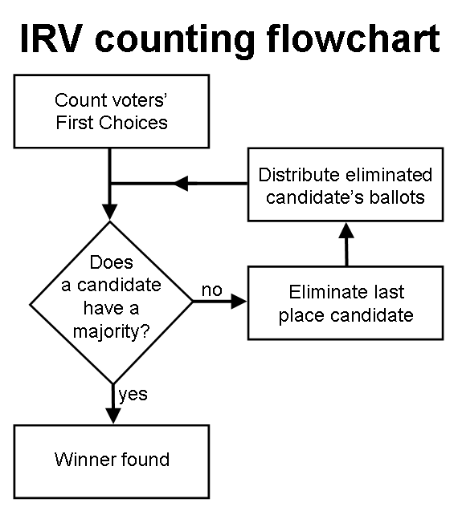

Dedicated Voting Section

- Specific section on Voting Process that can be applied to all the cases.

- Do not be overly prescriptive.

- Unify the way in which decisions are made, giving priority to e-vote.

- Simple majority (50%+1) of ASO AC will be the rule, and supermajority for a few special cases (to be defined).

- All votes must be public by rule and private vote as an exception (only for ICANN Board election, or other ICANN position (e.g. NomCom), or Chair election)

- Obligation for ASO AC members to justify abstention votes (it will only count towards quorum not majority)

- Voting processes will be conducted always (including only one candidate).

- What if only one candidate but

#### 